[https://www.matrix.edu.au](https://www.matrix.edu.au/quiz-whats-your-learning-style/)

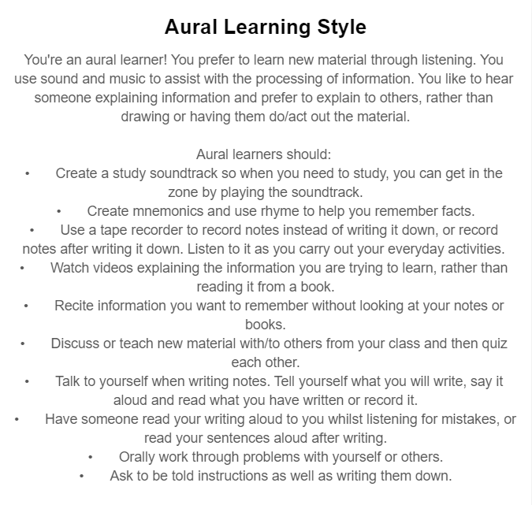

1. What do the results of these tests mean for you?

Judging from the outcome of these result, I can say I can relate to them as some of them do highlight my personality for studying. It shows how I would always prefer to have someone dictate the information to me and have a visual aid to help me understand the information.

It shows how I like to logically draw out my materials and verbally recite the information as I write them down again. Overall, I can see that the result of this test is quite accurate in terms of how I study and how I retain information.

1. How do you think these results may influence your behavior in a team?

I think once I know the result and how it defines my learning methods, from now on I might be more inclined to do what the quiz results outlined. Even when it is not necessarily required, I would do draw it out or get someone to dictate it to me. It will become an issue as sometime time does not permit to go through the whole process to learn something. Sometimes the situation requires me to quickly learn something and apply it in the context that I need.

1. How should you take this into account when forming a team?

When forming a team, I should take into account to have someone that is self-driven to stand up and lead the team, that way I can perform better. I should also seek someone that can quickly understand the material and that can dictate the key points back to the group to ensure they understand the material and what to do.